“Education is the movement from darkness into light” Allan Bloom

Mission
At Eclipse Education we believe that “every child matters” and every child deserves the opportunity to be the best version of themselves. We do this through equity of education, not equality.
Eclipse Education is an alternative education provider in BANES. We deliver education packages at KS3 and KS4 that meet the individual needs of each of our young people: both academically and therapeutically.
We aim to be both a place of safety for students and an environment where students are able to learn effectively in order to be empowered to be able to make better life choices and enjoy success in the future.

What we do?
All students will have a bespoke package designed for them with their talents, gaps in learning and individual needs in mind. Everyone will have a mixture of core / booster classes in English (Reading and Writing), Maths and Science; a wider curriculum in subjects that interest the young person, some holistic and therapeutic including ELSA, Music Therapy, Art Therapy as well as an enrichment package which is designed to develop ‘soft-skills’ such as problem solving, teambuilding and resilience.
We also deliver a robust PSHE curriculum which covers the main strands of health and wellbeing, economic wellbeing, relationships and living independently. Every young person also receives careers guidance from an experienced Careers teacher. We also organise and support ‘work shadowing’ placements and volunteering to help young people consider their options as well as experiencing the ‘real world.’

SEND
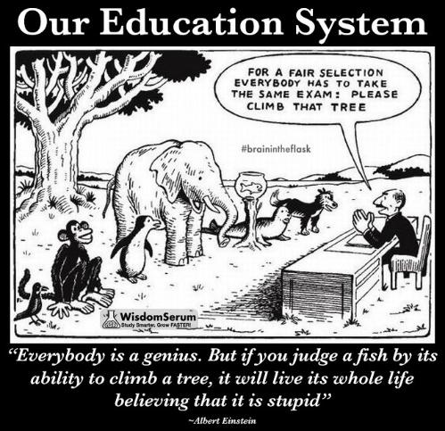
All Eclipse Education staff have experience of working with young people with SEND; including cognition and learning needs, speech and language difficulties and SEMH, including trauma. As such they are highly skilled in adapting the curriculum to meet a variety of needs and supporting students when they become disengaged or dysregulated. We teach our students to understand their needs and develop strategies that help them become the very best they can be, both in school and in their wider lives.
We offer 1:1 support for intimate care which includes feeding and changing. This is offered at a higher rate.

Preparing for next steps
Whether a child is returning to their ‘home-school’, moving on to a specialist placement, starting a post 16 provision or entering the world of work, Eclipse Education staff will support a carefully planned transition package to make sure this is successful. We have strong relationships in the Local Authority, local schools, colleges and employers.

Curriculum
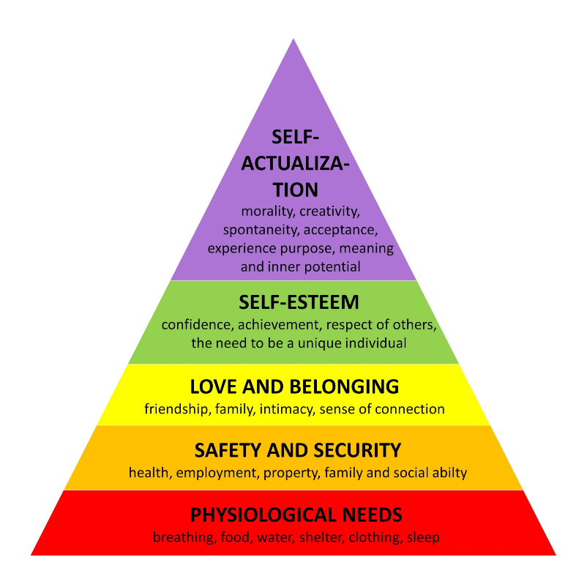
It is widely known that human beings have a hierarchy of needs, Maslow developed a pyramid of the needs that motivate people. Individuals most basic needs, at the base of the pyramid, are physiological. Once they have fulfilled these needs, people move on to their safety needs, social well-being, self-esteem then ultimately their need for self-actualization.
At Eclipse Education use Maslow’s Hierarchy to enhance learning through motivation. When all levels of Maslow’s Hierarchy of Needs are met, students show their full ability and eagerness for learning. The higher up in the hierarchy a student is, the better the motivation and therefore, the student will experience more effective learning.
Staff at the provision make sure that the needs on the lowest layer of the hierarchy are met before pushing them to reach the next level.

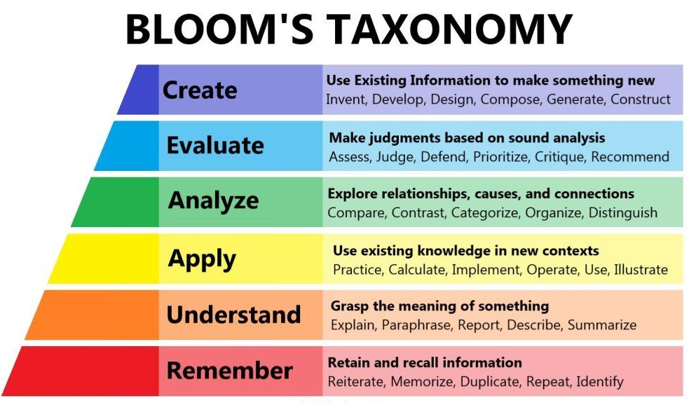
All staff also plan their sessions and interactions around Blooms Taxonomy so that they are appropriately pitched. Bloom's Taxonomy comprises three learning domains: the cognitive, affective, and psychomotor, and assigns to each of these domains a hierarchy that corresponds to different levels of learning. It's important to note that the different levels of thinking defined within each domain of the Taxonomy are hierarchical.

We use data provided by the referring provision to carefully design each child’s curriculum but also respond holistically dependant on a child’s presentation or experiences during each session.
All curriculums are designed with students achieving qualifications at the end of a designated period. These include academic qualifications such as Functional Skills Levels 1 and 2 or GCSEs, ASDAN qualifications, AQA unit awards and more practical certificates such as First Aid, Food Hygiene and even supporting students to obtain a CSCS card or pass their driving theory tests.

Staff CPD
Eclipse Education prides itself on having highly trained and motivated staff. ALL our staff have a minimum of:
Full DBS checks
Safeguarding level 2
Food Hygiene level2
Fire Safety Awareness training
Equality and Diversity training
Training to understand FGM, CSE, CCE, Child on Child abuse and Serious Violence
Mental Health Awareness training
PREVENT training

Staff complete regular training to update their skills to provide high quality and safe experiences that we can. Additional training is secured through the Virtual College and other reputable training providers including The Beacon School, The SEND Station and other experts in SEND. This is enhanced by staff having a firm understanding of pedagogy and cognition so that the students make as much progress as possible and achieve qualifications that recognise this. Teachers also attend training offered by course providers such as AQA, Edexcel and ASDAN.

